**IBIMENYETSO BYA KANSERI YA PROSTATE UKO IGENDA IGIRA UBUKANA**

Kwihagarika bigoraye kimwe n’urwaye adenome ya prostate, kuzana amaraso mu nkari cyangwa mu masohoro, kubabara mu magufa y’umugongo cyangwa mu rukenyerero (kanseri iba yageze mu magufa), kugira imbaraga nke mu maguru ndetse byanarimba amaguru akaremara

**URASABWA IKI?**

Guhera ku myaka 50, gana umuganga w’inzobere mu gusuzuma, gupima no kuvura indwara za prostate (Urologist).

**NI RYARI MUGANGA YEMEZA KO UFITE KANSERI YA PROSTATE ?**

**\*** Iyo isuzuma rya prostate n 'igipimo cy' umusemburo PSA biganisha ku gukeka kanseri ya prostate, muganga agusabira guca mu cyuma cya MRI kigaragaza utubyimba muri prostate.

* Nyuma y'ibyo, muganga agusaba gufata utunyama muri prostate yawe akatwohereza gupimwa muri laboratwari. Aha niho kanseri ya prostate n'ikigero cy'ubukana bwayo byemezwa burundu.

**KANSERI YA PROSTATE IVURWA ITE ?**

* Bitewe n'urugero indwara igezeho n'umwihariko w'umurwayi, kubaga prostate cyangwa kuyishiririza (radiotherapy) bifatwa nk ‘uburyo bwo gukiza iyo ndwara.

* Iyo indwara yarenze cyane prostate

**TUMENYE KANDI TWIRINDE KANSERI YA PROSTATE**





(metastases) hifashishwa uburyo bunyuranye bwo kubuza indwara kwihuta.





 : rwandaurologicalassociation@gmail.com:

: @RwandaUrology

5 6 1

**PROSTATE NI IKI?**

Prostate ni urugingo ruba munsi y’uruhago w’inkari rw’umugabo. Inkari zisohoka mu ruhago zinyura mu muyoboro wazo uhera muri prostate ugahinguka ku mutwe w’igitsina. Prostate ikora imisemburo yivanga n’intanga z’umugabo, zinjira muri prostate zivuye mu dusabo tw’intanga (testicles).

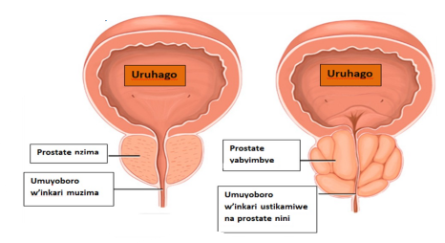

Prostate

**KANSERI YA PROSTATE NI NDWARA KI ?**

Kimwe n’izindi kanseri, kanseri ya prostate ni indwara ituruka ku kwivumbura k’uturemangingo tw' urwo rugingo, tugakura nabi kandi vuba, tukarema akabyimba muri prostate. Ako babyimba iyo katavuwe kohereza uturemangingo twako mu zindi ngingo z’umubiri (metastases) cyane cyane mu magufa y’umugongo.

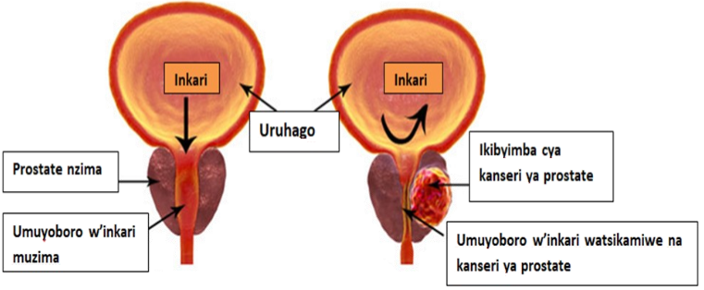

Mu barengeje imyaka 80 hafi icya kabiri baba bafite iyo ndwara ariko abenshi muri bo nta bimenyetso baba bafite. Kuyirinda ni ukumenya kare uko prostate yawe ihagaze, wegera muganga guhera ku myaka 50, agasuzuma prostate, akanagusabira ikizami kimwe cy'amaraso gipima imisemburo ya prostate (**PSA**). Nyuma yaho muganga aguha gahunda yo kugukurikirana bikakurinda gutahurwamo kanseri amazi yararenze inkombe.

\***Kavukire: A**bantu 10% barwara kanseri ya

prostate baba bayikuye ku mubyeyi wabo. ufite umubyeyi cyangwa umuvandimwe

Prostate !l!!

Kanseri ya prostate iyo igitangira nta bimenyetso umuntu aba afite, ari nayo

basanzemo kanseri ya prostate atarengeje imyaka 60, asabwa gutangira kwisuzumisha kare cyane (ku myaka 45).

***2. IBYO USHOBORA GUHINDURA***

Prostate igenda ibyimba uko imyaka yiyongera

ku buryo guhera hafi mu myaka mirongo itanu (50) prostate ishobora gutera kwihagarika nabi birimo umuvuduko muke w’inkari, kwikanira wihagarika, kwihagarika ntizishiremo, kwihagarika kenshi amanywa n’ijoro, rimwe na rimwe zikanagucika. Ubwo burwayi bwo kubyimba kwa prostate iyo butarimo kanseri bwitwa **ADENOME YA PROSTATE**. Ibyo bimenyetso bishobora no kugaragara kumuntu ufite **KANSERI YA PROSTATE.** Niyo mpamvu umugabo wese utugana afite ibyo bimenyetso

---tubanza gutandukanya izo ndwara zombi.

mpamvu tugira inama abantu kwisuzumisha kare (ku myaka 50) bakamenya uko bahagaze, batarindiriye ibimenyetso byo kwihagarika nabi, kwihagarika amaraso, kubabara mu magufa cyangawa guhuha amaguru.

**NI IBIKI BYONGERA IBYAGO BYO KURWARA KANSERI YA PROSTATE ?**

***1. IBYO UTABASHA GUHINDURA***

* **Imyaka:** Kanseri ya prostate ntipfa kuba mu bantu bari munsi y’imyaka 50. Ni indwara igaragara cyane mu bantu bakuze.

\***Ibyo kurya**: ku kigero gito, abagabo barya

ibikomoka ku mata byinshi barusha abandi ibyago byo kurwara kanseri ya prostate.

* **Umubyibuho ukabije**: ku kigero gito, abantu

babyibushye bikabije barusha abandi ibyago byo kurwara kanseri ya prostate.

**\* Ibindi:** kunywa itabi**,** guhura n’ibinyabutabire

byo mu nganda, kugira infection/inflammation ya prostate, guhura n’indwara zandurira mu mibonano mpuzabitsina nk’imitezi, ibyo byose byongera ibyago byo kurwara kanseri ya prostate, ariko ku kigero gito.

2 3 4